Photography in Motion: Muybridge, Morgan & Edgerton
22 August 2026 – 24 January 2027
1 | 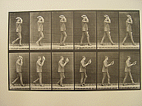 | Edweard Muybridge  American, b. in Britain, 1830 – 1905  Man in Suit with Straw Hat (PLATE 44, from Animal Locomotion), 1887  collotype  Bequest, Levi W. Mengel  1997.1.426.28C
2 | 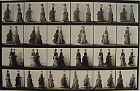 | Edweard Muybridge  American, b. in Britain, 1830 – 1905  Two Women Walking and Passing (PLATE 45, from Animal Locomotion), 1887  collotype  Bequest, Levi W. Mengel  1997.1.426.29C
3 | 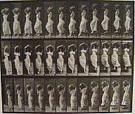 | Edweard Muybridge  American, b. in Britain, 1830 – 1905  Descending stairs and turning, a water jar on left shoulder (PLATE 146 from Animal Locomotion), 1887  collotype  Bequest, Levi W. Mengel  1997.1.426.59C
4 | 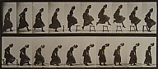 | Edweard Muybridge  American, b. in Britain, 1830 – 1905  Woman Jumping Over Stool (PLATE 156, from Animal Locomotion), 1887  collotype  Bequest, Levi W. Mengel  1997.1.426.67C
5 | 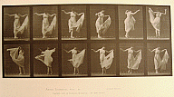 | Edweard Muybridge  American, b. in Britain, 1830 – 1905  Dancing Woman (PLATE 187, from Animal Locomotion), 1887  collotype  Bequest, Levi W. Mengel  1997.1.426.84C
6 | 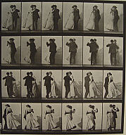 | Edweard Muybridge  American, b. in Britain, 1830 – 1905  Man and Woman Dancing (PLATE 197, from Animal Locomotion), 1887  collotype  Bequest, Levi W. Mengel  1997.1.426.90C
7 | 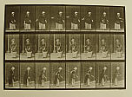 | Edweard Muybridge  American, b. in Britain, 1830 – 1905  Lawn Tennis (PLATE 296, from Animal Locomotion), 1887  collotype  Bequest, Levi W. Mengel  1997.1.426.162C
8 | 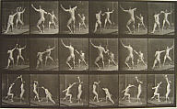 | Edweard Muybridge  American, b. in Britain, 1830 – 1905  Men Fencing (PLATE 350, from Animal Locomotion), 1887  collotype  Bequest, Levi W. Mengel  1997.1.426.201C
9 | 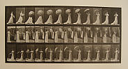 | Edweard Muybridge  American, b. in Britain, 1830 – 1905  Woman Opening a Parasol and Turning Around (PLATE 461, from Animal Locomotion), 1887  collotype  Bequest, Levi W. Mengel  1997.1.426.272C
10 | 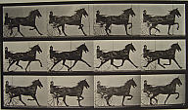 | Edweard Muybridge  American, b. in Britain, 1830 – 1905  “Reuben” trotting, harnessed to sulky (PLATE 606, from Animal Locomotion), 1887  collotype  Bequest, Levi W. Mengel  1997.1.426.352.3C
11 | 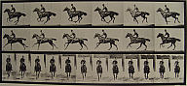 | Edweard Muybridge  American, b. in Britain, 1830 – 1905  'Bouquet' Galloping, saddled (PLATE 632, from Animal Locomotion), 1887  collotype  Bequest, Levi W. Mengel  1997.1.426.358C
12 | 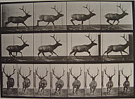 | Edweard Muybridge  American, b. in Britain, 1830 – 1905  Elk Galloping (PLATE 695, from Animal Locomotion), 1887  collotype  Bequest, Levi W. Mengel  1997.1.426.374C
13 | 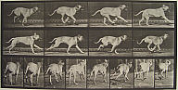 | Edweard Muybridge  American, b. in Britain, 1830 – 1905  Dread (Dog running), (PLATE 707, from Animal Locomotion), 1887  collotype  Bequest, Levi W. Mengel  1997.1.426.381C
14 | 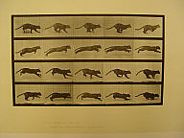 | Edweard Muybridge  American, b. in Britain, 1830 – 1905  Cat Galloping (PLATE 719, from Animal Locomotion), 1887  collotype  Levi W. Mengel  1997.1.426.386C
15 | 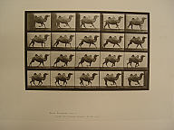 | Edweard Muybridge  American, b. in Britain, 1830 – 1905  Bactrian Camel Running (PLATE 739, from Animal Locomotion), 1887  collotype  Levi W. Mengel  1997.1.426.397C
16 | 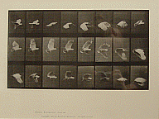 | Edweard Muybridge  American, b. in Britain, 1830 – 1905  Cockatoo Flying (PLATE 758, from Animal Locomotion), 1887  collotype  Bequest, Levi W. Mengel  1997.1.426.410C
17 | 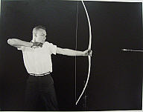 | Harold Edgerton  Ouch!, 1934  gelatin silver  Gift, Edgerton Family Foundation  2010.1.1
18 | 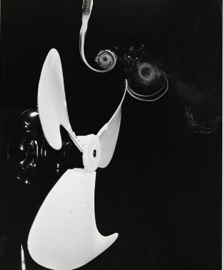 | Harold Edgerton  Fan & Smoke Vortices, 1934  gelatin silver  Gift, Edgerton Family Foundation  2010.1.2
19 | 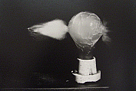 | Harold Edgerton  Bullet through Bulb, 1936  gelatin silver  Gift, Edgerton Family Foundation  2010.1.3
20 | 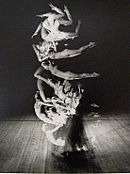 | Harold Edgerton  Tumblers Multiflash, 1942  gelatin silver  Gift, Edgerton Family Foundation  2010.1.4
21 | 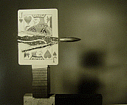 | Harold Edgerton  Bullet through Jack, 1960  gelatin silver  Gift, Edgerton Family Foundation  2010.1.5
22 | 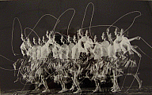 | Harold Eugene Edgerton  American, 1903 - 1990  Moving Skip Rope, 1952  Gift, Edgerton Family Foundation  2010.1.6
23 | 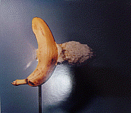 | Harold Eugene Edgerton  American, 1903 - 1990  Bullet through Banana, 1964  color dye transfer  Gift, Edgerton Family Foundation  2010.1.7
24 | 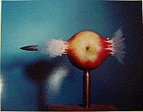 | Harold Edgerton  American, 1903 - 1990  Bullet through Apple, 1964  color dye transfer  Gift, Edgerton Family Foundation  2010.1.8
25 | 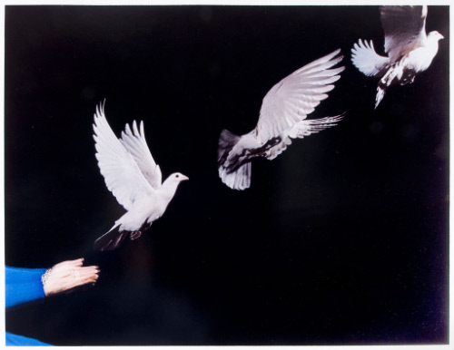 | Harold Eugene Edgerton  American, 1903 - 1990  Pigeon Released, 1965  color dye transfer  Gift, Edgerton Family Foundation  2010.1.9
26 | 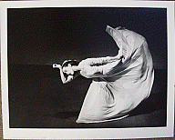 | Barbara Morgan  American, 1900 – 1992  Martha Graham – Letter to the World, (Kick), 1940  gelatin silver print  Gift, William and Leena Kipp  2012.19.4
27 | 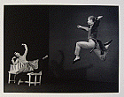 | Barbara Morgan  American, 1900 – 1992  Martha Graham – Letter to the World  (with Merce Cunningham “Dear March Come In”), 1940  gelatin silver print  Museum Purchase  2012.20.1
28 | 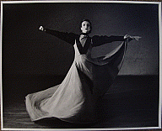 | Barbara Morgan  American, 1900 – 1992  Doris Humphrey – With My Red Fires (Matriarch), 1938  gelatin silver print  Museum Purchase  2012.20.6
29 | 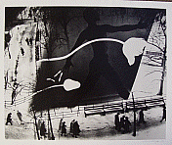 | Barbara Morgan  American, 1900 – 1992  Spring on Madison Square, 1938  gelatin silver print  Gift, William and Leena Kipp  2013.1.2
30 | 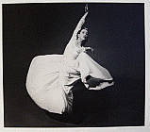 | Barbara Morgan  American, 1900 – 1992  Martha Graham – Letter to the World (Swirl), 1940  gelatin silver print  Gift, William and Leena Kipp  2013.1.3
31 | 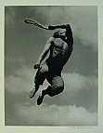 | Barbara Morgan  American, 1900 – 1992  Martha Graham – El Penitente  (Solo Erick Hawkins – El Flagellante), 1940  gelatin silver print  Gift, William and Leena Kipp  2013.1.4
32 | 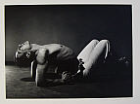 | Barbara Morgan  American, 1900 – 1992  José Limón – Mexican Suite (Peon), 1944  gelatin silver print  Museum Purchase  2013.1.5
33 | 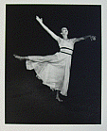 | Barbara Morgan  American, 1900 – 1992  Doris Humphrey – Passacalgia, 1938  gelatin silver print  Gift, William and Leena Kipp  2012.19.2
34 | 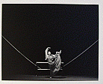 | Barbara Morgan  American, 1900 – 1992  Martha Graham – Frontier, 1935  gelatin silver print  Museum Purchase  2012.20.2
35 | 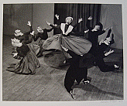 | Barbara Morgan  American, 1900 – 1992  Doris Humphrey – Shakers, 1938  gelatin silver print  Museum Purchase  2012.20.8

